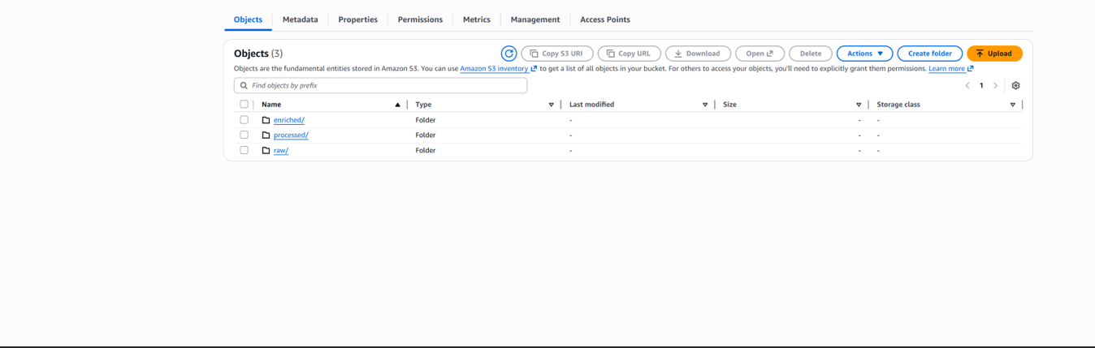

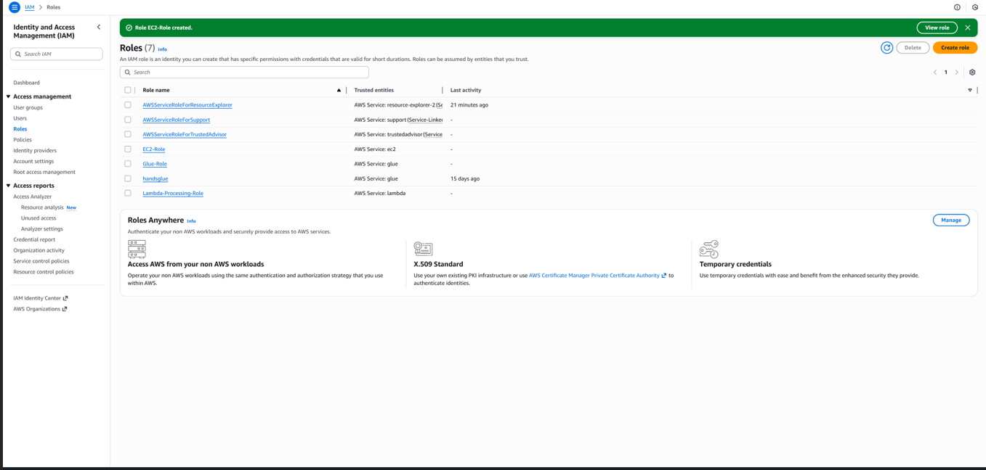

ProcessOrders
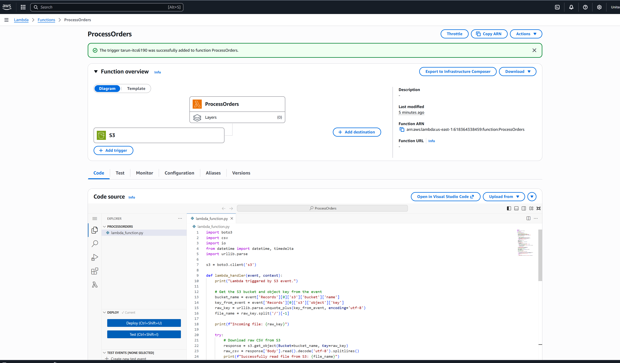
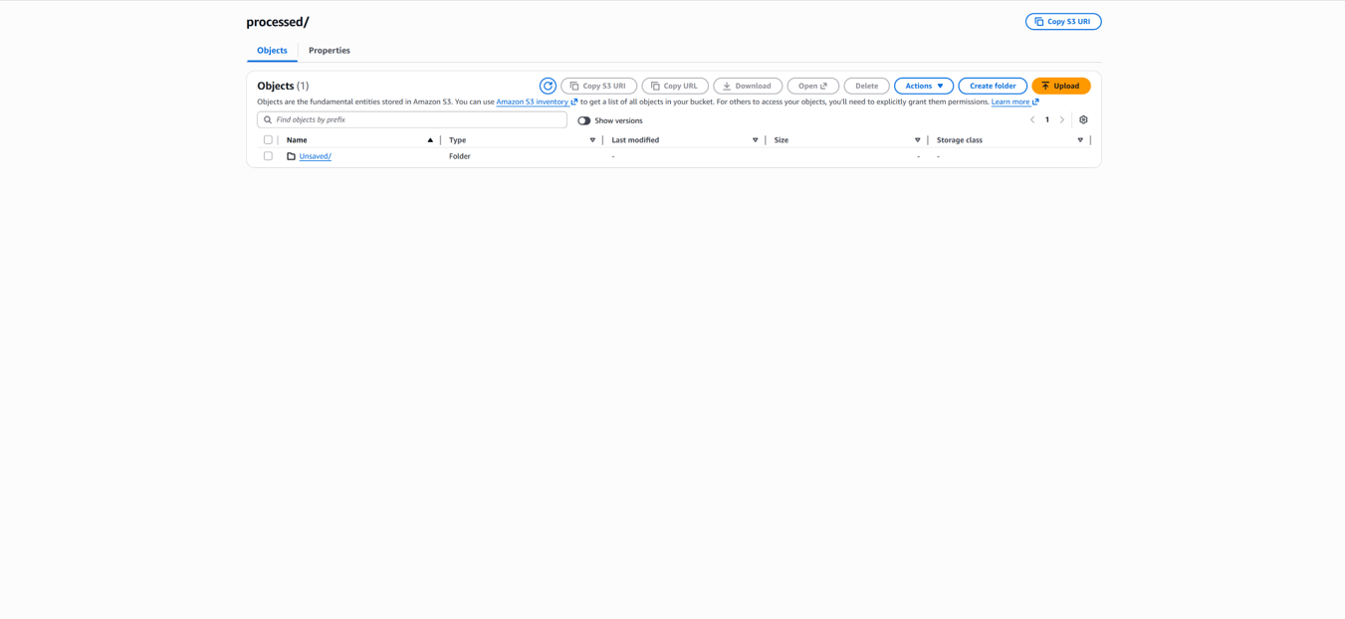

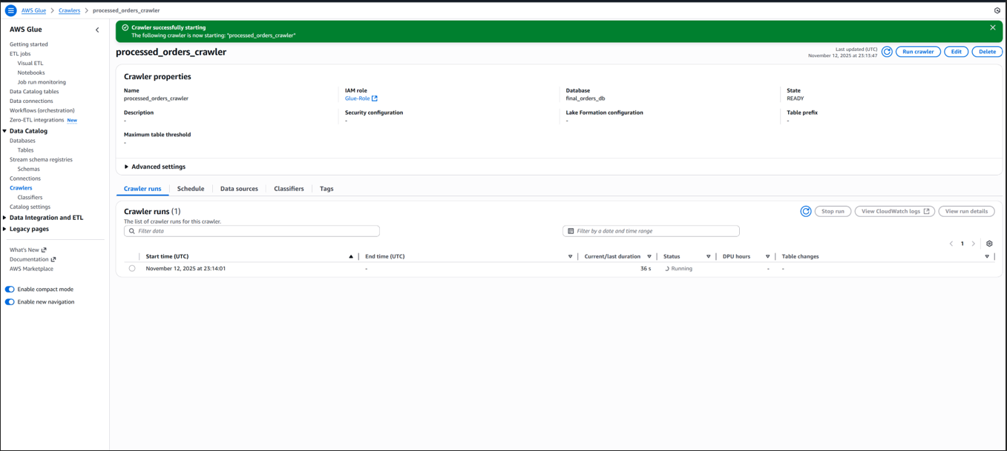

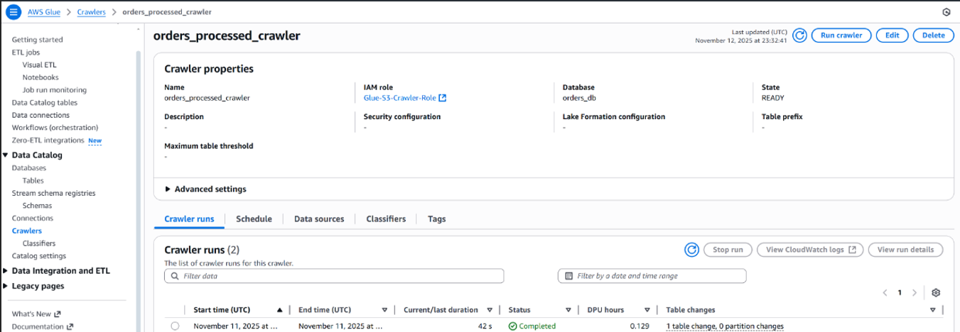

Query 1: Top-Selling Products
Business Question: Which products generate the most revenue and sales volume?
SELECT
productid,
COUNT(orderid) AS total_orders,
SUM(amount) AS total_revenue,
ROUND(AVG(amount), 2) AS avg_order_value
FROM processed
GROUP BY productid
ORDER BY total_revenue DESC
LIMIT 10;
Insight: Identifies the best-performing products to prioritize for inventory, promotions, or restocking.

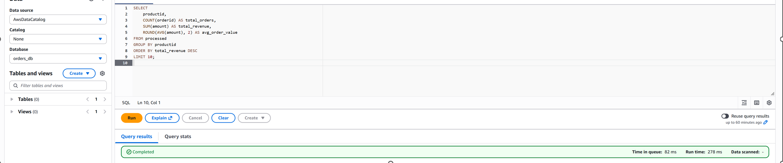

Query 2: Revenue by Region or Country
Business Question: Which regions or countries contribute most to total revenue?
SELECT
region,
COUNT(orderid) AS total_orders,
SUM(amount) AS total_revenue,
ROUND(AVG(amount), 2) AS avg_order_value
FROM processed
GROUP BY region
ORDER BY total_revenue DESC;
Insight: Helps target high-performing regions for marketing and expansion while identifying underperforming areas.

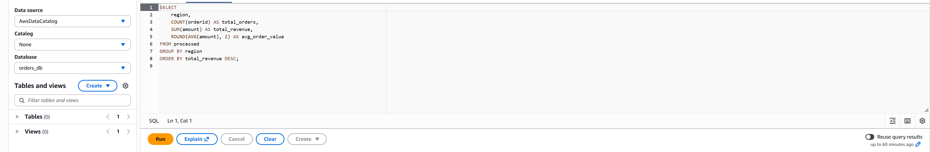
Query 3: Payment Method Performance
Business Question: Which payment methods are most commonly used and generate the most revenue?
SELECT
paymentmethod,
COUNT(orderid) AS total_orders,
SUM(amount) AS total_revenue,
ROUND(AVG(amount), 2) AS avg_order_value
FROM processed
GROUP BY paymentmethod
ORDER BY total_revenue DESC;
Insight: Assists in understanding customer preferences and optimizing payment options to improve checkout experience.

